Object Oriented Programming
Lab

SPRING - 2023

LAB 08


FAST National University of
Computer and Emerging Sciences

Learning Outcomes

In this lab you are expected to learn the following:

● Static Data Members
● Copy Constructor
Static Data Member:

Static data members are class members that are declared using static keyword. Only one copy of that member is created for the entire class and is shared by all the objects of that class, no matter how many objects are created.

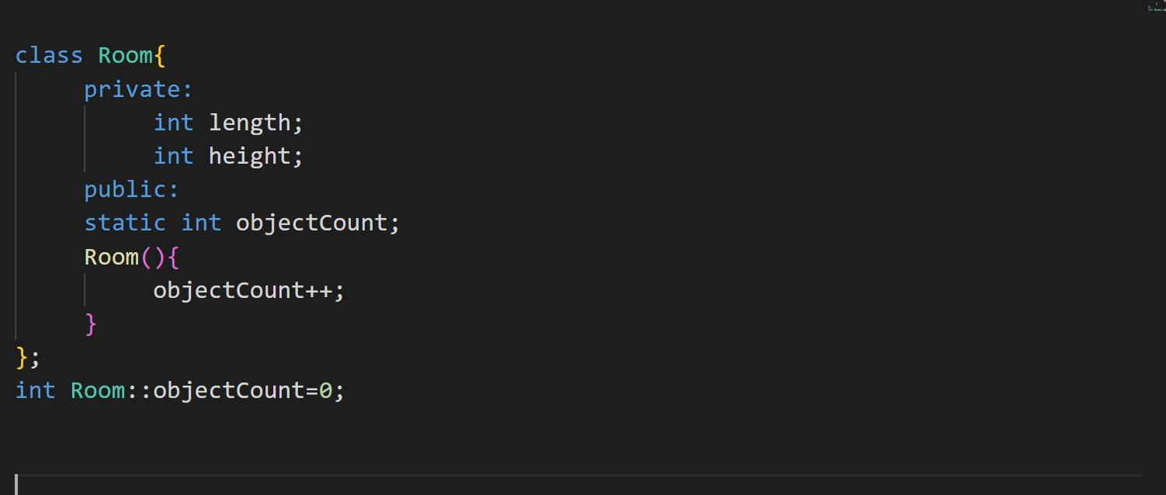Syntax: static data_type data_member_name; For example,

Here, we defined a class named Room.
The variables length, breadth, and height declared inside the class are known as data members. And, the objectCount data member is a static data member that contains the number of objects created of class Room. Room() is a constructor that increments objectCount each time a new class object is created.

Copy Constructors:

A copy constructor is a member function that initializes an object using another object of the same class.
For Example,

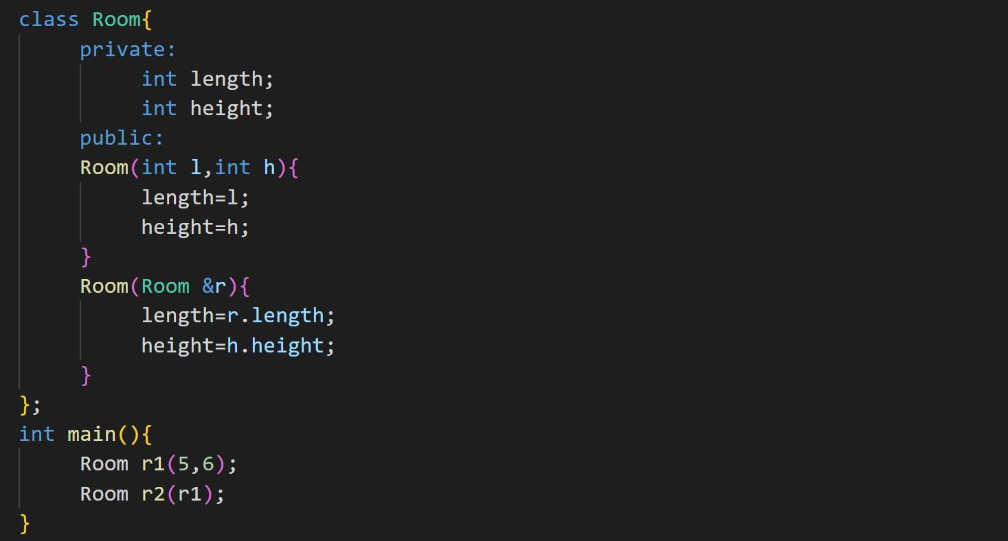
Lab Tasks

Submission Instructions:
1. Now create a new folder with name ROLLNO_SEC_LAB01 e.g. i23XXXX_A_LAB07
2. Move all of your .cpp and .h files to this newly created directory and compress it into a
.zip file
3. Now you have to submit this zipped file on Google Classroom.
4. If you don’t follow the above-mentioned submission instruction, you will be marked zero.
5. Plagiarism in the Lab Task will result in zero marks in the whole category.

Q 1. Write a class Distance with the following private data members:

- int feet

- int inch

Then implement member functions;

1. Write a default constructor

1. Overloaded constructors

- Distance(int f, int i) // parameterized constructor

- Distance(Distance &copy) // copy constructor

2. Create setter and getter methods for all data members

3. Write following member function in the class

- Distance addDistance(Distance &d2)

It add both distance and returns newly generated distance.

- Distance subDistance(Distance &d2)

It subtract both distance and returns newly generated distance.

- void display()

It prints the distance.

1. Example 1:

Use Copy Constructor to assign values

- D1(15,8), D2(10,7)

- Addition: (26,3)

- Subtraction: (5,1)

Q 2.

Your goal in this question is to write a program to manage a Parking Garage. For this you will need to create a class Parking Garage that should be able to simulate a basic parking garage will the following functionalities:

Your garage should have a fixed capacity (5 cars at most). For each car stationed at your garage, you will record its entry time (current day hour in 24h format), its registration number and its allocated slot (each car can be allocated parking slot 1 to 5). A new car cannot be parked if the garage capacity is already full.

Whenever a new car arrives at your garage you will add it to the garage if the capacity is not full. When a car leaves the garage you will ask the user current time (hour in 24h format) and charge him Rs 20 per hour and removes car from the end of the array.

Identify all data members and write them. Your class must provide following member functions.

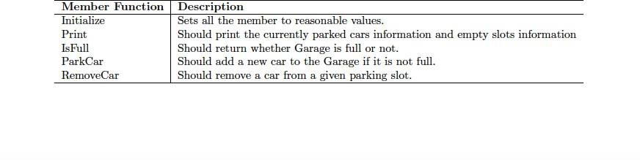

Q 3.

Your goal in this question is to write a program to manage a ShoppingList. For this you will need to create a class ShoppingList that should be able to store all the details of shopping items with the following functionalities:

Your ShoppingList has a fixed capacity 10 of ShoppingItems. For each ShoppingItem, you will store its name, its quantity, and its price. A new ShoppingItem cannot be added to ShoppingList if the list is already full. Whenever you buy a new item you will add it to the ShoppingList if the capacity is not full.

Identify all data members of these classes and write them. Your classes must provide following member functions.

